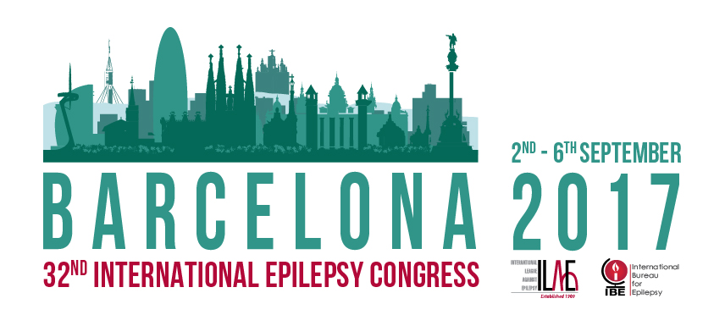
Nomination Form
Ambassador for Epilepsy Award 2017

Introduction
The Ambassador for Epilepsy Award, a unique award introduced by IBE President Mrs Ellen Grass in 1968, is given jointly by the International Bureau for Epilepsy (IBE) and the International League Against Epilepsy (ILAE). The Award is bestowed on individuals to recognise outstanding contributions to activities that advance the cause of epilepsy. These contributions and activities should either be performed at an international level or they should have an international impact or significance. Recipients of the award are referred to, in short, as 'Ambassadors'. The award consists of an Ambassador for Epilepsy pin and scroll. The recipient will be invited to attend the 32nd International Epilepsy Congress, Barcelona 2017 – http://www.epilepsybarcelona2017.org, to receive the award and will be offered free (non-transferrable) registration to the congress.
Who can nominate
All ILAE and IBE Chapters, and all members of the Joint Executive Committees of the ILAE and the IBE are invited to nominate up to a maximum of 4 candidates to be considered for this award. Nominations from ILAE and IBE Chapters must be submitted by a duly authorised officer of the nominating association.
Nomination process
Before preparing a nomination, please ensure that the candidate has not already received the award. You can do so by checking the IBE website http://www.ibe-epilepsy.org/about/awards/, where you will find the full list of recipients. Or you may contact the IBE office ibeexecdir@eircom.net to request a listing. Be sure to submit all nominations well in advance of the deadline of 31st December 2016 - late submissions will not be considered. Do not submit any more than 4 nominations for this award. Please refer to the Rules for the Ambassador for Epilepsy Awards for full information on the nomination process.
Notes There is a limit of 700 words (approximately one typed page each) for information on the nominees international activities and on their other activities. Additional informatin may not be considered in selection of those to receive the award.

Nominees Details
Name of Nominee:
Address:
City:
Country:
Email:
Chapter/Association affiliation (if applicable):
Profession/Occupation:

History of international activities (700 words maximum)

Other relevant activities (700 words maximum)

Nominated by:
Name:
Address:
Country:
Email:
Association:
Position/Title:
Date:

IMPORTANT NOTES

The closing date for the receipt of nominations is 31st December 2016. Please make sure that you submit all nominations in good time to allow delivery before the closing deadline. No nominations received after the closing date will be considered for an award. It is important to read the Rules for the Ambassador for Epilepsy Awards to make sure that nominations follow correct procedures. If you have any queries, please do not hesitate to contact ibeexecdir@eircom.net.

Please submit the completed nomination by emailing to ibeexecdir@eircom.net.
Alternatively, nominations may be sent by mail to: International Bureau for Epilepsy, 7 Priory Office Park, Stillorgan Road, Blackrock, Co Dublin, A94 FN26, Ireland.

