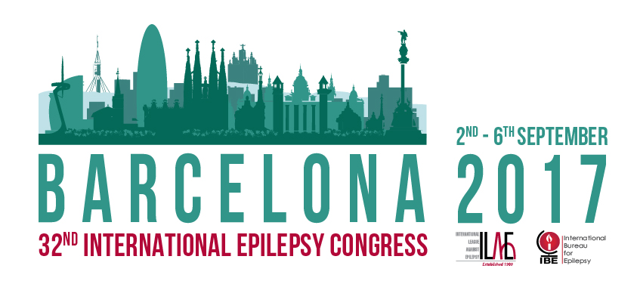
Nomination Form
Social Accomplishment Award 2017

Introduction
The Social Accomplishment in Epilepsy Award is given jointly by the International Bureau for Epilepsy (IBE) and the International League Against Epilepsy (ILAE). The Award is given to an individual to recognise his or her outstanding personal contribution to activities that have resulted in a significant advance in the social well-being and/or quality of life of people with epilepsy. These contributions and activities should either have been performed at an international level or they should have had an international impact or significance. The Award reflects international peer recognition. It consists of an engraved glass trophy, to a maximum value of US$500 and a financial prize of US$5,000. The recipient will be invited to attend the 32nd International Epilepsy Congress, Barcelona 2017, to receive the award and will be offered free (non-transferrable) registration to the congress. The name of each recipient will be added to the Award Winners' Hall of Fame.
Who can nominate
ILAE and IBE Chapters, and members of the Joint Executive Committees of the ILAE and the IBE are invited to submit a nomination to be considered for this award. Nominations from ILAE and IBE Chapters must be submitted by a duly authorised officer of the nominating association.
Nomination process
Before preparing a nomination, please ensure that the candidate has not already received the award. You can do so by checking the IBE website http://www.ibe-epilepsy.org/about/awards/, where you will find the list of recipients, or you may contact the IBE office ibeexecdir@eircom.net to request a list. Be sure to submit the nomination well in advance of the deadline of 31st December 2016 - late submissions will not be considered. Please refer to the Rules for the Social Accomplishment in Epilepsy Awards for full information on the nomination process.
Notes
There is a limit of 700 words (one typed page approximately) each for information on the nominee's social activities and other achievements that you believe qualify the person being nominated to be considered for the award. Additional informatin may not be considered in selection of those to receive the award.
Nominees Details
Name of Nominee:
Address:
Country:
Email:
Chapter/Association affiliation (if applicable):
Profession/Occupation:

History of social activities (700 words maximum)

Other achievements (700 words maximum)

Nominated by:
Name:
Address:
Country:
Email:
Association:
Position/Title:
Date:

IMPORTANT NOTES

The closing date for the receipt of nominations is 31st December 2016. Please make sure that you submit all nominations in good time to allow delivery before the closing deadline. No nominations received after the closing date will be considered for an award. It is important to read the Rules for the Social Accomplishment Awards to make sure that nominations follow correct procedures. If you have any queries, please do not hesitate to contact ibeexecdir@eircom.net.

Please submit the completed nomination by emailing to ibeexecdir@eircom.net.
Alternatively, nominations may be sent by mail to: International Bureau for Epilepsy, 11 Priory Office Park, Stillorgan Road, Blackrock, Co Dublin, A94 FN26, Ireland.

