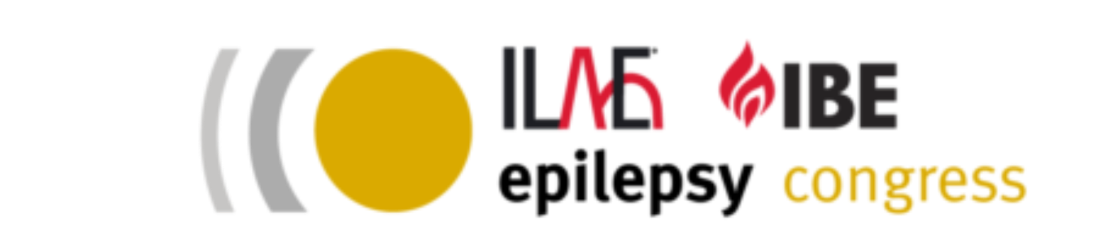

14th AOEC Art Exhibition Entry Form

Please email this form along with your art entry to communications@ibe-epilepsy.org no later than Friday, 4th November 2022.

Entrants under 12 years of age may have the Entry Form completed on their behalf by a parent or guardian.

Name

E-mail

Country

Title of Entry
Please enter in English.

Short Description
Please enter in English. Max 200 words.

By ticking the box below, you consent to grant IBE, free of charge, the right to publish the entry online, in other IBE media, or as part of an exhibition.

I consent

Do you wish to have your entry considered for International Epilepsy Day 2023?

Yes
No

